**Predicting The Energy Output Of Wind Turbine Based On Weather Conditions By Using Machine Learning**

**SHOUVIK KHAN**  
*Mechanical Engineering*  
**Meghnad Saha Institute Of Technology**Kolkata, India  
shouvik_k.me2019@msit.edu.in

**PARTHAJIT RANA**  
*Mechanical Engineering*  
**Meghnad Saha Institute Of Technology**Kolkata, India  
parthajit_r.me2019@msit.edu.in **SAYANTAN DAS**  
*Mechanical Engineering*  
**Meghnad Saha Institute Of Technology**Kolkata, India  
sayantan_d.me2019@msit.edu.in

**SATTRAJIT SAHA**  
*Mechanical Engineering*  
**Meghnad Saha Institute Of Technology**Kolkata, India  
sattrajit_s.me2019@msit.edu.in

**SOMNATH DAS**  
*Mechanical Engineering*  
**Meghnad Saha Institute Of Technology**Kolkata, India  
somnath_d.me2019@msit.edu.in **MIRAJUL HOQUE**  
*Mechanical Engineering*  
**Meghnad Saha Institute Of Technology**Kolkata, India  
mirajul_h.me2019@msit.edu.in

**PANKAJ KUMAR**  
*Mechanical Engineering*  
**Meghnad Saha Institute Of Technology**Kolkata, India  
pankaj_k.me2019@msit.edu.in

**Abstract—**Renewable energy is the most important topic in the world at present. It was identified that the fossil fuel reserves in the world are diminishing rapidly and no reserves were identified. In addition to that, energy generation from fossil fuels may cause many environmental problems like emission of greenhouse gasses, global warming and acid rains. Renewable energy sources play a major role in this type of situation Renewable energy is the energy that is extracted from renewable sources such as Winds, Sunlight, Rain, Tides, Waves,Geothermal heat etc.Wind power is the fastest-growing form of renewable energy at the present time in terms of reduced mechanical stress, improved power quality high system efﬁciency, and reduced acoustic noise

**Keywords*—***wind energy, windfarm , renewable energy, and energy***.***

# **Introduction**

# A wind turbine is a device that has three basic parts–a tower, blades, and a generator. These parts work together to convert energy from the wind into electrical energy Wind turbines work on a simple principle: instead of using electricity to make wind like a fan. Wind turbines use wind to make

# 

# electricity. Wind turns the propeller-like blades of a turbine around a rotor, which spins a generator, which creates electricity.

# Wind is a form of solar energy caused by a combination of three concurrent events:

# The sun unevenly heating the atmosphere

# Irregularities of the earth's surface

# The rotation of the earth

Wind flow patterns and speeds vary greatly and are modified by bodies of water, vegetation, and differences in terrain. Humans use this wind flow, or motion energy, for many purposes: sailing, flying a kite, and even generating electricity.

The terms "wind energy" and "wind power" both describe the process by which the wind is used to generate mechanical power or electricity. This mechanical power can be used for specific tasks (such as grinding grain or pumping water) or a generator can convert this mechanical power into electricity.

A wind turbine turns wind energy into electricity using the aerodynamic force from the rotor blades, which work like an airplane wing or helicopter rotor blade. When wind flows across the blade, the air pressure on one side of the blade decreases. The difference in air pressure across the two sides of the blade creates both lift and drag. The force of the lift is stronger than the drag and this causes the rotor to spin. The rotor connects to the generator, either directly (if it’s a direct drive turbine) or through a shaft and a series of gears (a gearbox) that speed up the rotation and allow for a physically smaller generator. This translation of aerodynamic force to rotation of a generator creates electricity.

Countries like Germany and India are showing a strong appetite for wind energy generation due to useful wind speed prediction capability. The role of wind power prediction is becoming increasingly crucial, while the wind penetration rate is continuously growing. Every power system has a reasonable capability to adapt demand changes as the demand estimation has never been entirely accurate. When the penetration rate is relatively low, power systems do not have to pay too much attention to the variance of wind power supply.

Machine learning is a field of computer science that focuses on improving the performance of the program by itself with experience. In this technique, the machine is not told how to solve the problem explicitly; instead, the experience is given to the device as different inputs, and the outputs are typically a model that can address future issues of the same kind. The complete procedure of machine learning includes several steps. First, past experience is usually gathered for the training in the later stage. At that point, the type of a unique target function is resolved, which portrays the relationship between inputs and outputs. From that point onward a machine learning model is chosen to estimate the target function. At last, a fitting calculation is utilized to assemble the model from the training models. The process of machine learning is summarized in

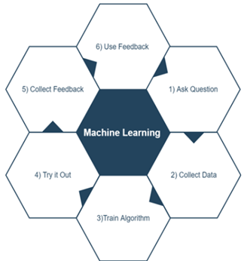

Fig-1 Summary of machine learning

The elimination of variability of the wind is not possible, but by using machine learning, we can make wind power sufficiently more predictable and valuable. This will also help bring greater data rigor to wind farm operations, as these techniques can help wind farm operators make faster, more data-driven, and smarter assessments of how their power output can meet electricity demand. The primary aim of this research work is to predict wind turbine output power using machine learning techniques. Since a very limited study has been done on wind turbine power prediction using machine learning it is of greater interest to us how well it performs in this field. The remaining sections of this study are structured as follows: In section II we will discuss the literature review related to power prediction in wind energy. Section III briefly describes the methodology of this study. Section IV presents the results and discussion of the study and finally, in section V this study will conclude with the future work direction.

**2**.  **LITERATURE REVIEW**

1. Global energy demand is increasing, and the use of nuclear power, traditional sources of energy such as coal and oil is either considered unsafe or leads to a large amount of CO2 emission.
2. One the other hand, wind is a natural free energy source.
3. This is extremely unpredictable, which is a major problem for the incorporation of massive wind power into an energy grid.
4. Present power production by wind farms is very less than the requirements for solving various problems.
5. With the improvement of forecasting wind speed and wind direction, it is possible to maximize power production of a wind farm.

**3. METHODOLOGY**

This section will explain the methodology used in this research work. Firstly we will discuss the wind turbine data collection. The data obtained from SCADA is preprocessed in the second step before the data analysis. Thirdly, the useful features are selected from the data. In the fourth step, the machine learning model is trained using the data. In the last step the wind turbine power is predicted. The complete flow of methodology is shown in Fig 3.

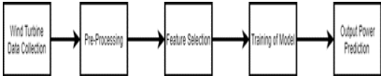

Fig. 3 Methodology of the study.

**a . Wind Turbine Data Collection**

In every wind turbine farm the Supervisory control and data acquisition (SCADA) is already installed which collects the data from different sensors. The dataset for this research work is obtained from the wind farm in France. The wind farm consists of 4 wind turbines. The data contain data from 1st January 2017 to 29th January 2018 for each turbine. The collected data is recorded after every 10 minutes.

All installed wind turbines have same specifications which is show in Table I

TABLE I WIND TURBINE SPECIFICATIONS USED IN THIS STUDY

| Rated Power | 2050kW |
| --- | --- |
| Cut-in Wind Speed | 3.5 m/s |
| Cut-out Wind Speed | 25 m/s |
| Nominal Wind Speed | 14.5 m/s |
| Diameter | 82 m |
| Rotor area | 5281 m2 |
| Length of rotor blades | 40 m |

**b. Data pre-processing**

The model accuracy of wind turbines is highly affected by inaccurate SCADA data caused by null entries and irregular operation. Therefore it is really important to pre-process this data which will remove these confusing entries before further analyses. The SCADA data collected have a mismatch in date and time which is fixed using Python. The data is further cleaned by applying the cut in and cut out wind speed limit. The data contain some negative output power which is an unphysical value which is removed before further analysis. The pitch angle of a wind turbine also consists of some irregular value which normally is very low or slightly negative so before further analysis the data is excluded. The wind speed and Power of the wind turbine after preprocessing is shown in Fig 4 and Fig 5 respectively.

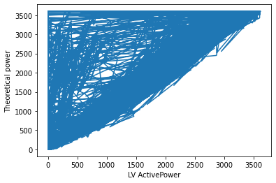

Fig. 4 Wind speed after pre-processing

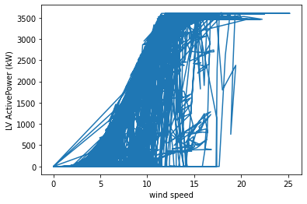

# Fig. 5. Output power of wind turbine after preprocessing.

**C. Feature Selection**

The features selected for this model are wind turbine generator ambient (external) conditions. The parameters selected for this research are absolute wind direction (Wa), wind speed (Ws) and outdoor temperature (Ot). The average, minimum, maximum and standard deviation values of all four features are considered while analysis.

**D. Training of Model**

The dataset after pre-processing and features selection is divided into test and training sets. The training model is shown in Fig 6 . The total data set consists of 100 samples. The data of wind turbines for year 2017 is selected as a training set while data for year 2018 for the month January is used for the prediction of output power of one of the wind turbines.

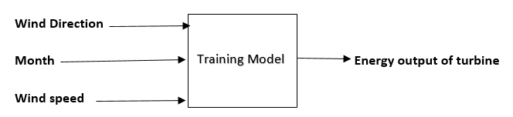

Fig. 6. Inputs and output of the proposed model

**4. RESULTS AND DISCUSSION**

According to the wind speed and wind direction in different months the model gives the required power produced in the turbine.Wind speed,wind direction,month is taken as the input in the model.Active power is taken as the output which is the power produced in the turbine.

Therefore By analysing the given data, we can say that PE is increasing with AT and V. While PE is decreasing with the increment of AP. So, in order to increase energy production of power plants (PE), we need to operate combined cycle power plants at low AT, low V, high RH, and high AP. There can be some more Data Science Techniques which can be applied to find some more patterns from the given dataset.

**5. CONCLUSIONS AND FUTURE WORK**

The result of this paper is a powerful method for precise and efficient wind power prediction using machine learning. The SCADA data collected from 2 MW wind turbines in the wind farm in France from 1st January 2017 to 29th January 2018 were used to forecast the output power of the wind turbines. The data is pre-processed before the analysis for better performance. Wind turbine output power for the year 2018 is forecast using the 2017 measurements. The use of appropriate features helps to improve the prediction. We used the absolute wind direction, wind speed and outdoor temperature to predict output power . We estimate the wind turbine performance by the capacity factor for real power output and annual effected power output. Random forest regressor machine learning model to predict the output power.

This project presents a technical application of the recent progress of We will be considering the Random Forest, Linear Regression model based processing. It will be predicting full load electrical power output, in order to maximize the profit from the available megawatt hour. Furthermore, the finding from the model building to the pros and cons of the model are also specified. In addition, applications, future focus, and solutions are provided. At present, the design and use of this Random Forest, Regression model. Our ultimate goal is to use Machine Learning through algorithms of Random Forest, Regression model tools to predict the energy output.

Most wind power forecasting models that study ‘regular’ wind conditions aim to improve wind power prediction over challenging and extreme weather periods and at different temporal and spatial scales. Development activities are ongoing to reduce error in the wind power prediction, to improve regionalized wind power forecasting for on - shore wind.

**6.** **Model Working**

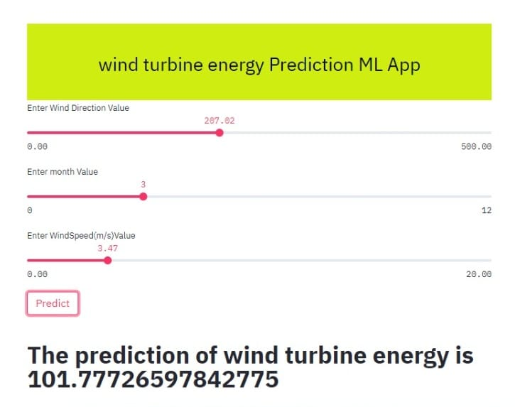

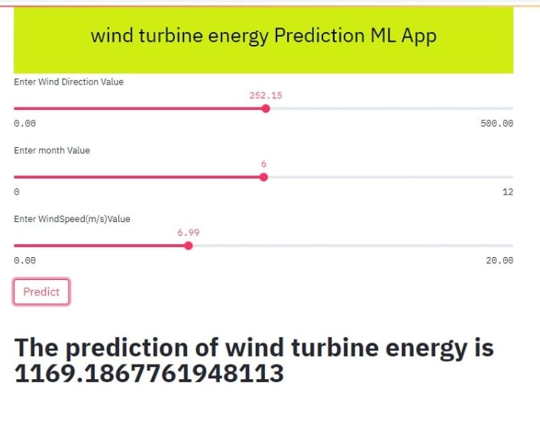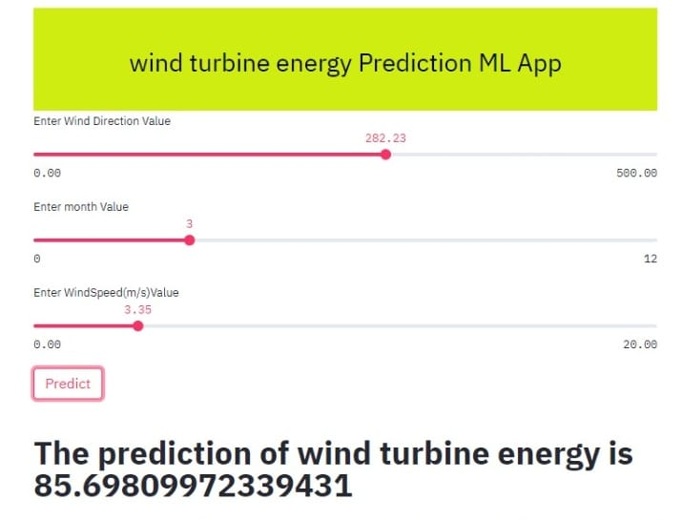

**REFERENCES**

1. **B. Kanna and S. N. Singh, ”Long term wind power forecast using adaptive wavelet neural network,” in 2016 IEEE Uttar Pradesh Section International Conference on Electrical, Computer and Electronics Engineering (UPCON), 2016, pp. 671-676.**
2. **Council, Global Wind Energy. "Global wind statistics 2019." Global Wind Report (2020).**
3. **S. Baran, ”Probabilistic wind speed forecasting using Bayesian model averaging with truncated normal components,” Computational Statistics Data Analysis, vol. 75, pp. 227-238, 2014/07/01/ 2014.**
4. **Mitchell, T. M. :Machine Learning. Singapore: McGraw-Hill Companies, Inc” 1997.**
5. **The European Wind Energy Association. Wind in power – 2015 European statistics. https: // windeurope. org/ wp-content/ uploads/ files/ about-wind/ statistics/ EWEA-Annual-Statistics-2015. pdf . 2016.**
6. **Long-term wind speed and power forecasting using local recurrent neural network models IEEE Trans. Energy Convers.**
7. **Brower M 2012 Wind Resource Assessment: A Practical Guide to Developing a Wind Project (New York: Wiley).**